Microreact Practical Guide
Genomic Data Visualization and Analysis

Purpose
This guide provides a standardized workflow for preparing, configuring, exploring, saving, and sharing genomic data in Microreact.

Background
The increasing availability of pathogen genomic data presents both opportunities and challenges for understanding pathogen evolution, transmission, and geographic spread. Integrating phylogenetic information with epidemiological and genomic metadata can be particularly challenging when analyzing large numbers of isolates. Conventional phylogenetic trees often provide limited ability to simultaneously visualize temporal, geographic, and other epidemiologically relevant characteristics.
Microreact, developed by the Centre for Genomic Pathogen Surveillance (CGPS), supports the interactive exploration of phylogenetic trees, geographic maps, timelines, and related metadata such as collection date, location, lineage, and other epidemiological characteristics. Users can apply colors, shapes, filters, and custom layouts to examine patterns across linked views. Microreact projects can also be saved and shared with other users, facilitating collaborative analysis and communication of genomic epidemiological findings.

Disclaimer:
DPH uses an internal version of Microreact for analyses involving metadata that may contain protected health information (PHI). This practical exercise uses only de-identified information, allowing participants to use the public version of Microreact.

Practical Materials

Practical Files


Stage 1: Prepare the Data

Step 1: Receive the Microreact Project File from the Laboratory
- Receive the initial .microreact project file or project link from the laboratory.
- Confirm that the package includes the sequencing metadata, phylogenetic tree, and SNP-distance information needed to build the project.

Step 2: Open the Project in Microreact
- Go to: https://microreact.org
- Select Upload.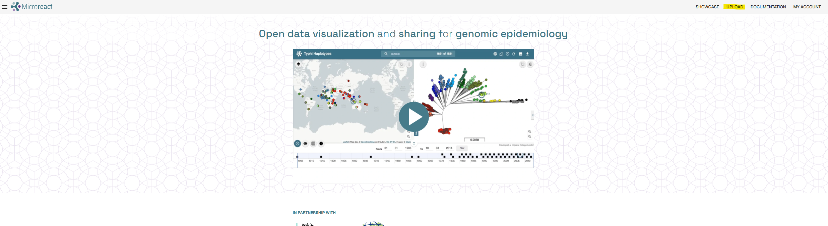

- Drag and drop the .microreact file into the upload area.
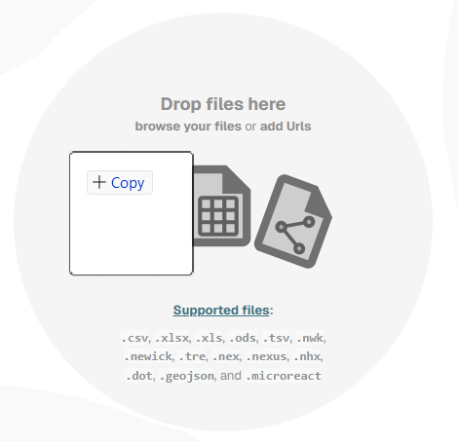
- Confirm that the project loads correctly and includes the expected components:
  - Phylogenetic tree
  - Sample metadata
  - SNP-distance or clustering outputs (for example, Snippy and PopPUNK)
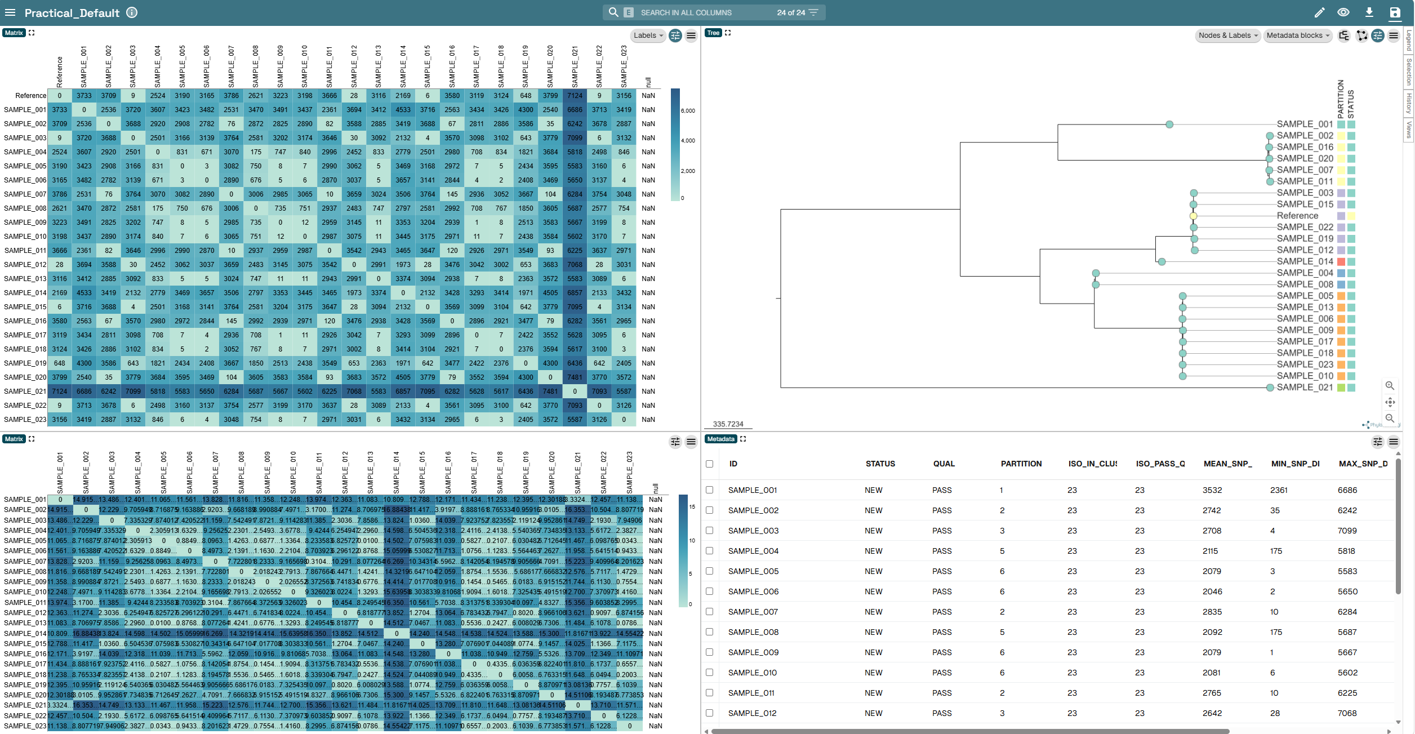

Step 3: Download the Required Metadata File
- Open the metadata table in the lower-right panel.
- Open the three-line menu.
- Select Download as CSV.
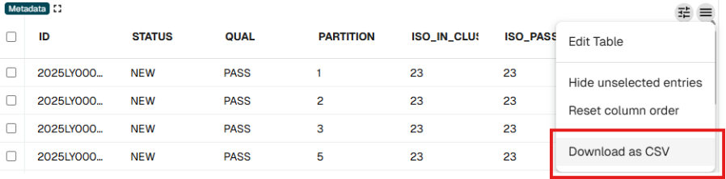

Downloaded file:

Step 4: Merge Epidemiologic and Sequencing Metadata
- Open the epidemiologic metadata file.
- Open the downloaded sequencing metadata file.
- Copy columns B–W from the epidemiologic metadata file into the sequencing metadata file.
Before
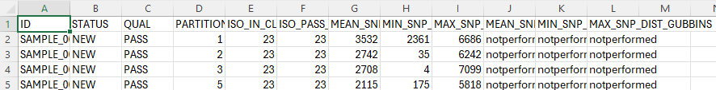
After
Example Epidemiologic Metadata Fields
  - CX_FACILITY: Collection facility
  - FAC_TYPE: Facility Type
  - PAT_NUM: De-identified patient number
  - SOURCE: Specimen source
  - PAIRS_LESS_THAN_10: Indicates whether an isolate pair within the cluster differs by fewer than 10 SNPs
  - CLUSTER: Group of isolates clustered using epidemiologic and whole-genome sequencing data
  - LAT: Collection-facility latitude
  - LON: Collection-facility longitude
  - YEAR: Year extracted from the specimen-collection date
  - MONTH: Month extracted from the specimen-collection date
  - DAY: Day extracted from the specimen-collection date
  - Phoenix_result: Resistance mechanisms

Stage 2: Configure the Microreact Project

Step 5: Replace the Project Metadata File
- Select the pencil icon in the upper-right corner.
- Select Edit Existing Panels.

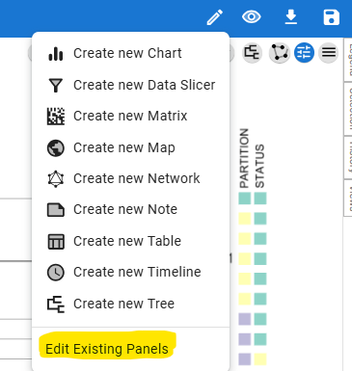

- Select Metadata, and then select the Replace File button.
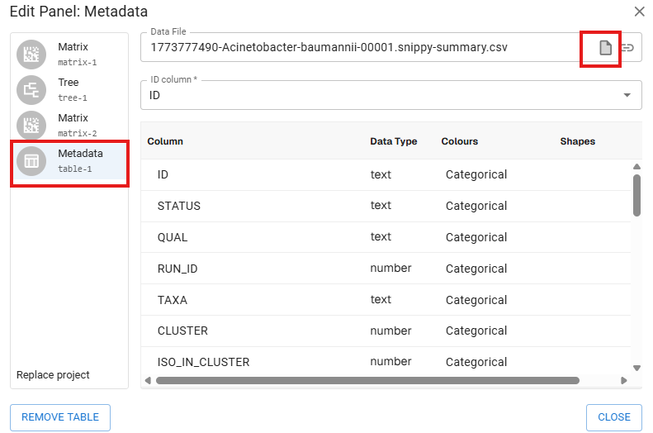

- Select the updated metadata file created in Step 4.
- Select Close. The project now uses the updated metadata file.
Important: Retain the original metadata variables and append the new epidemiologic fields. Do not replace the original variables.

Step 6: Add Metadata Blocks to the Phylogenetic Tree
- Open the Metadata Blocks menu in the upper-right corner.
- Select the desired metadata blocks. Examples include CX_FACILITY, SOURCE, PAIRS_LESS_THAN_10, EPI_CLUSTER, FAC_TYPE, and resistance-mechanism fields such as bla_adc_73 through bla_oxa_225.
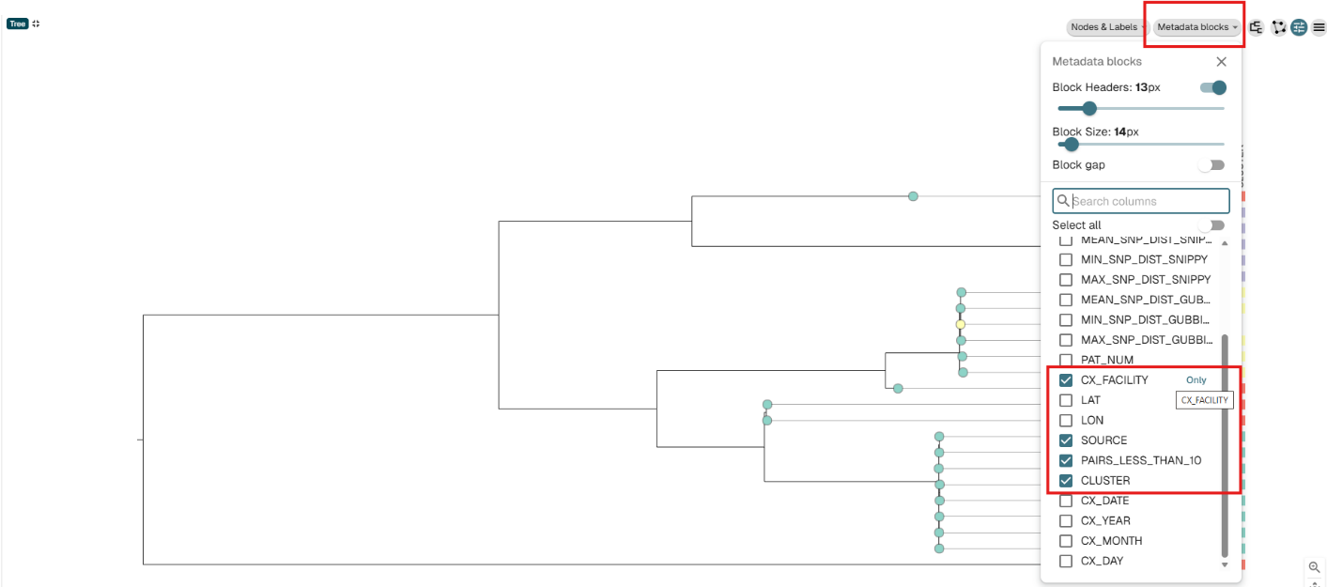

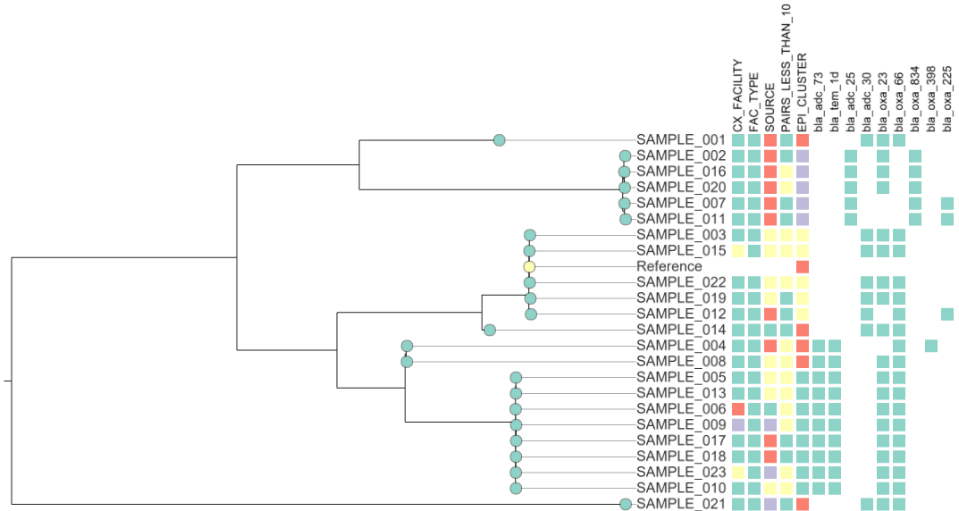
- Use Label Column to display custom labels and Colour Column to choose the preferred block color.

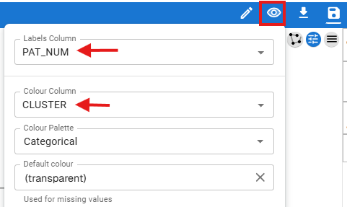

Cluster definitions combine epidemiologic and whole-genome sequencing information. Epidemiologic criteria may include specimen source, healthcare exposure, and specimen-collection dates; genomic criteria may include tree partitioning, root-to-tip distance, and an SNP threshold.

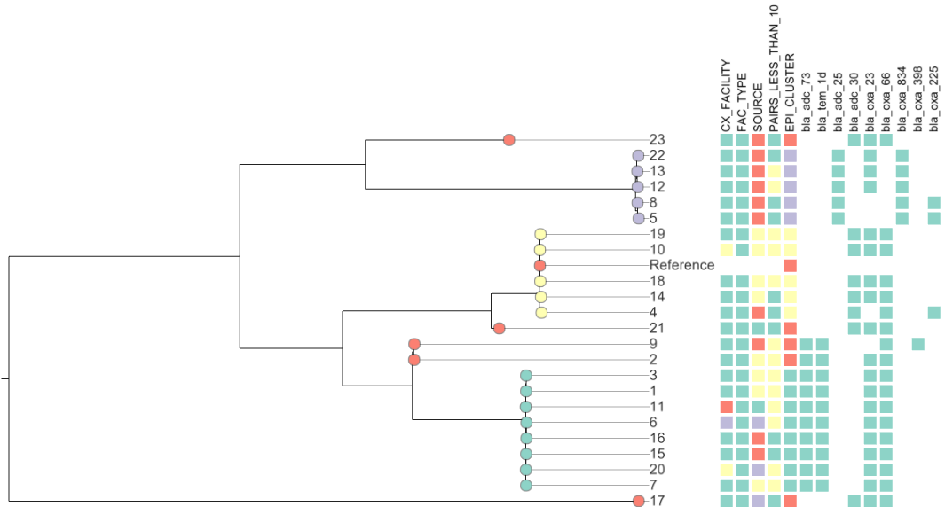

Step 7: Add a Timeline (Epidemic Curve)
- Select the pencil icon in the upper-right corner.
- Select Create New Timeline.
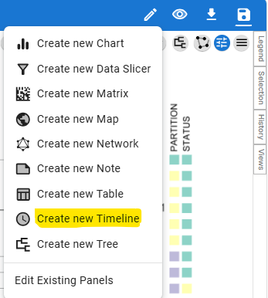

Choose where the timeline panel should appear.
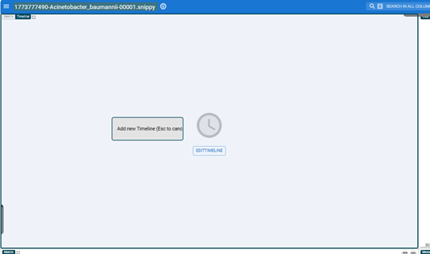
Map the YEAR, MONTH, and DAY metadata columns to the corresponding timeline fields.
Use the following date formats:
  - YEAR = YYYY
  - MONTH = MM
  - DAY = DD
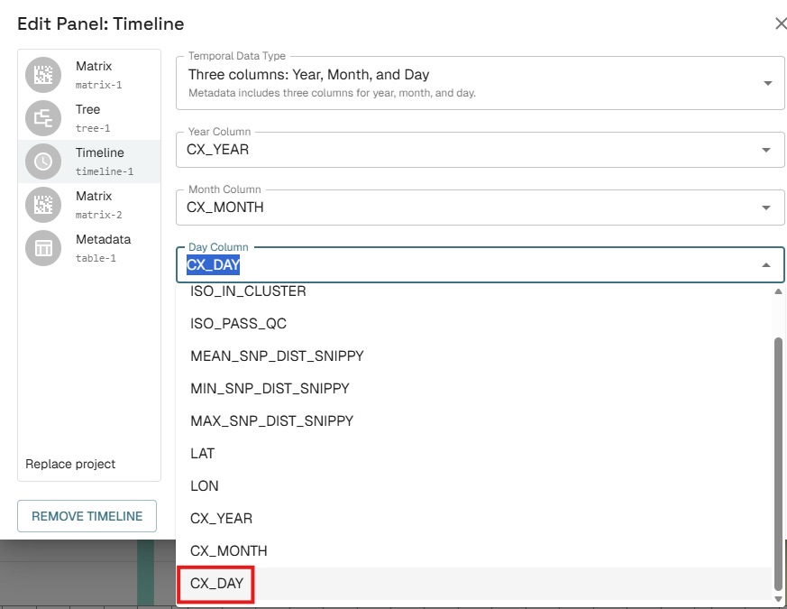

- Select Close.
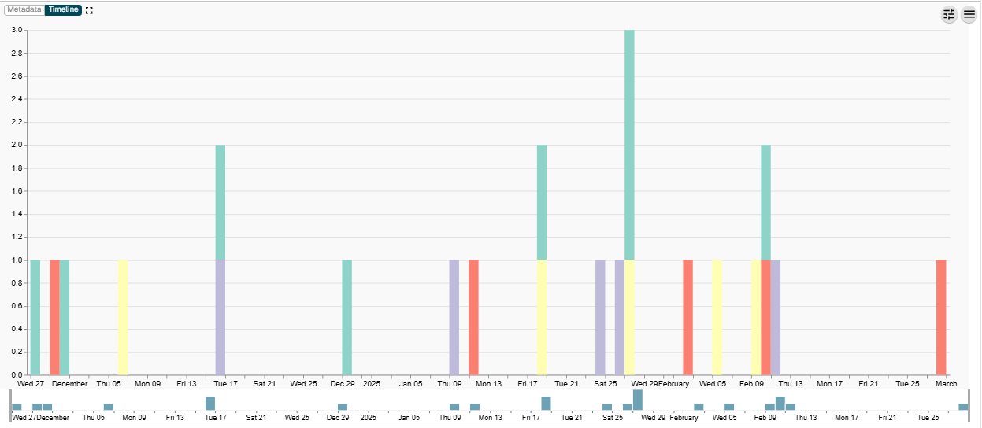
Optional: Test the playback feature in the timeline.

Step 8: Add a Map Using Latitude and Longitude
- Select the pencil icon, and then select Create New Map.

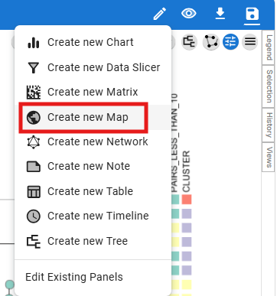
- Choose where the map panel should appear.
- Map the LAT and LON columns to the latitude and longitude fields.
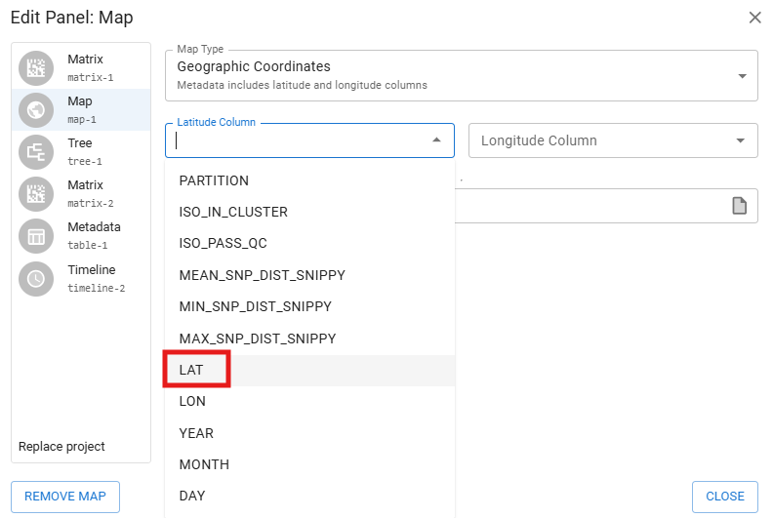
- Select Close, review the map, and zoom in as needed.
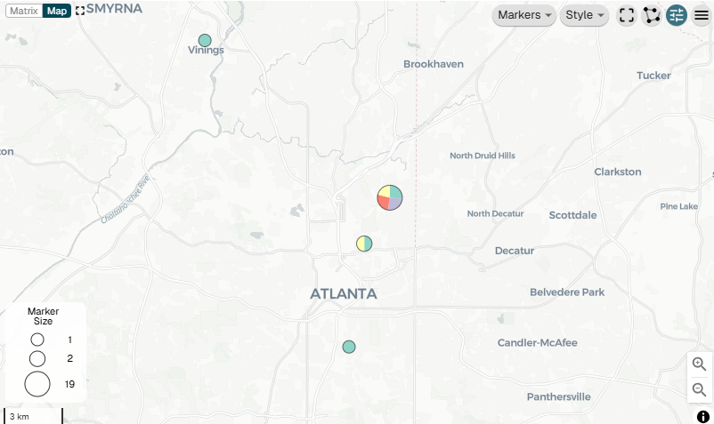
Optional: Customize the map, including marker scale and style.
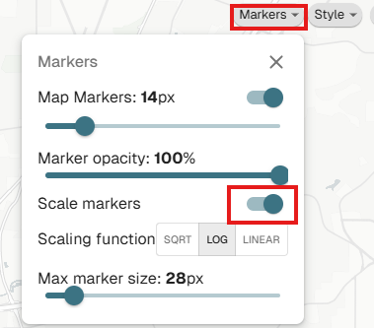

Step 9: Add a Pie Chart
- Open the panel-creation menu.
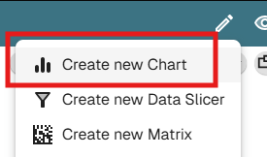
- Choose the panel location (for example, Bottom Left).
- Open Chart Type, and then select Pie Chart.
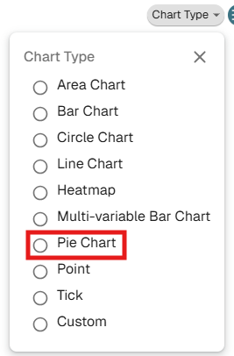
- Open Categories.

- Select EPI_CLUSTER.
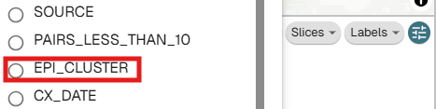
Optional: Open Labels and turn on Show Percentages. Labels inside slice.

Step 10: Create and Save Dashboard Views
Start with the current overview layout.
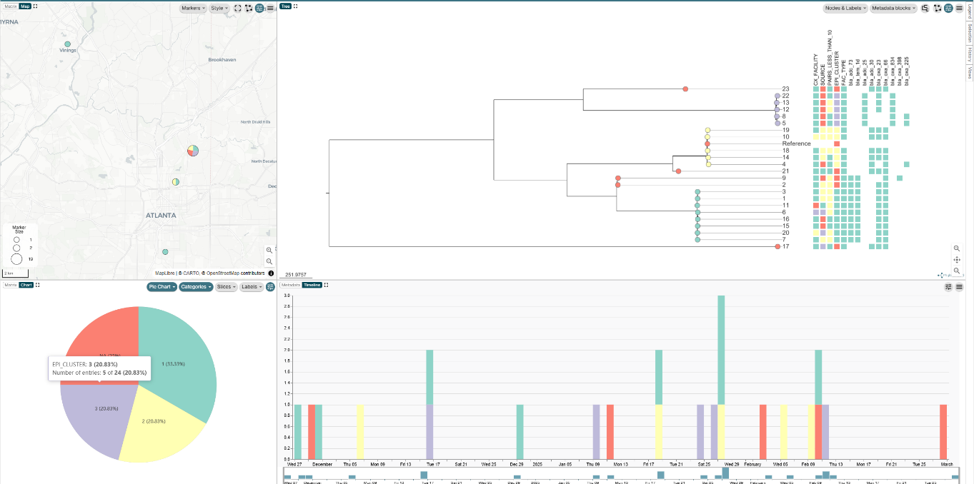
- Open the Views tab in the upper-right corner.
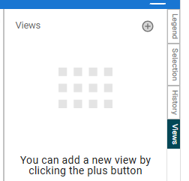
- Select the plus (+) button to save the initial view.
- Rename view to “Overview”
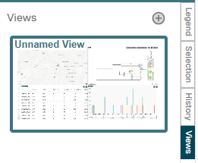
Add new View.
- Select the plus (+) button again to create a second view.
Rename the second view Cluster Analysis.
Add a data slicer.
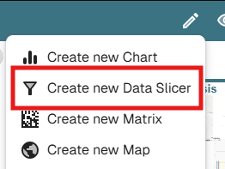
- Choose a column.

- Select EPI_CLUSTER as the data column.
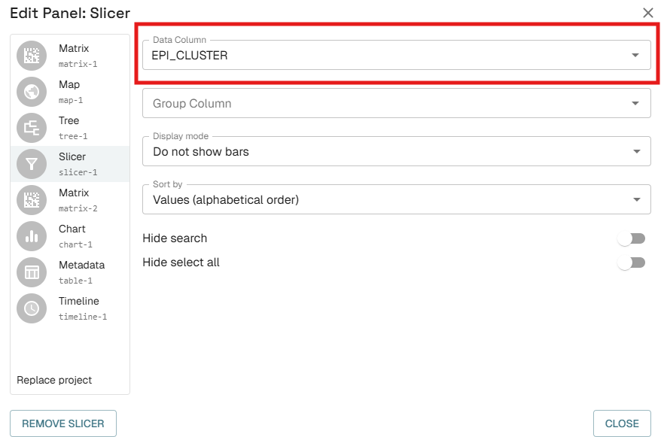
Add a new chart.
- Set Chart Type to Multi-variable Bar Chart.
- Open Columns and select all resistance-mechanism fields.
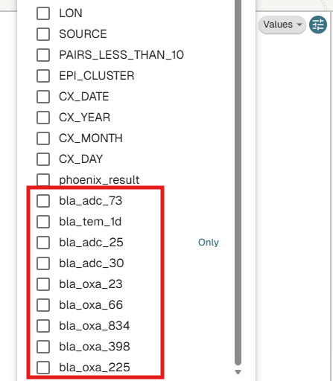
- Open Values.
- Select All values except blanks.
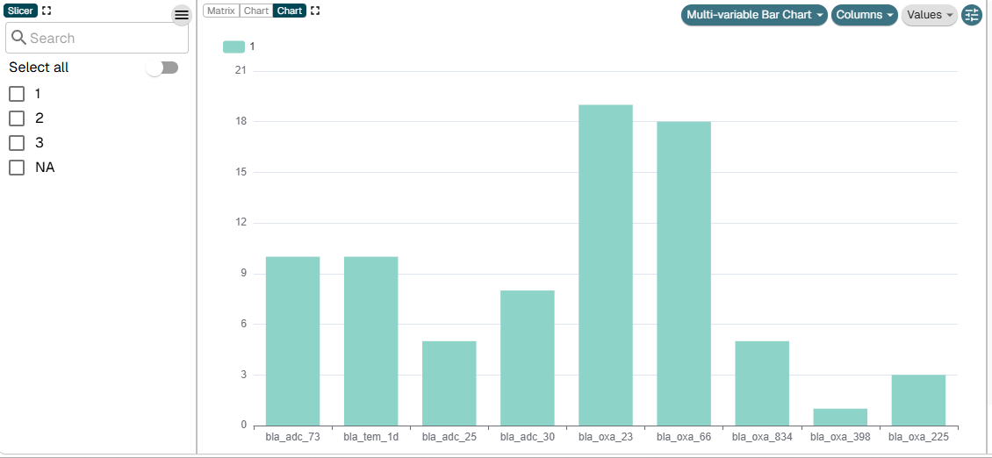
Add another chart and select Pie Chart.
- Set Categories to SOURCE.
- Drop down “Slices” activate “Exclude blank values”
Completed cluster-analysis view
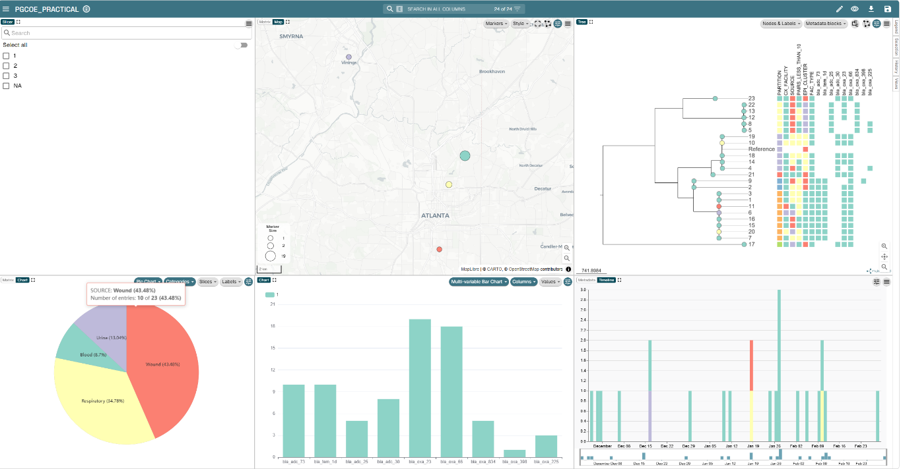
Important: After editing a view, hover over its thumbnail, open the three-dot menu, and select Update View. Otherwise, the changes will not be saved.

Saving view

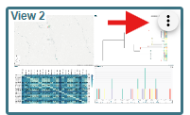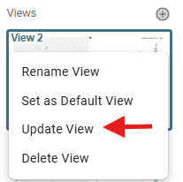
Result
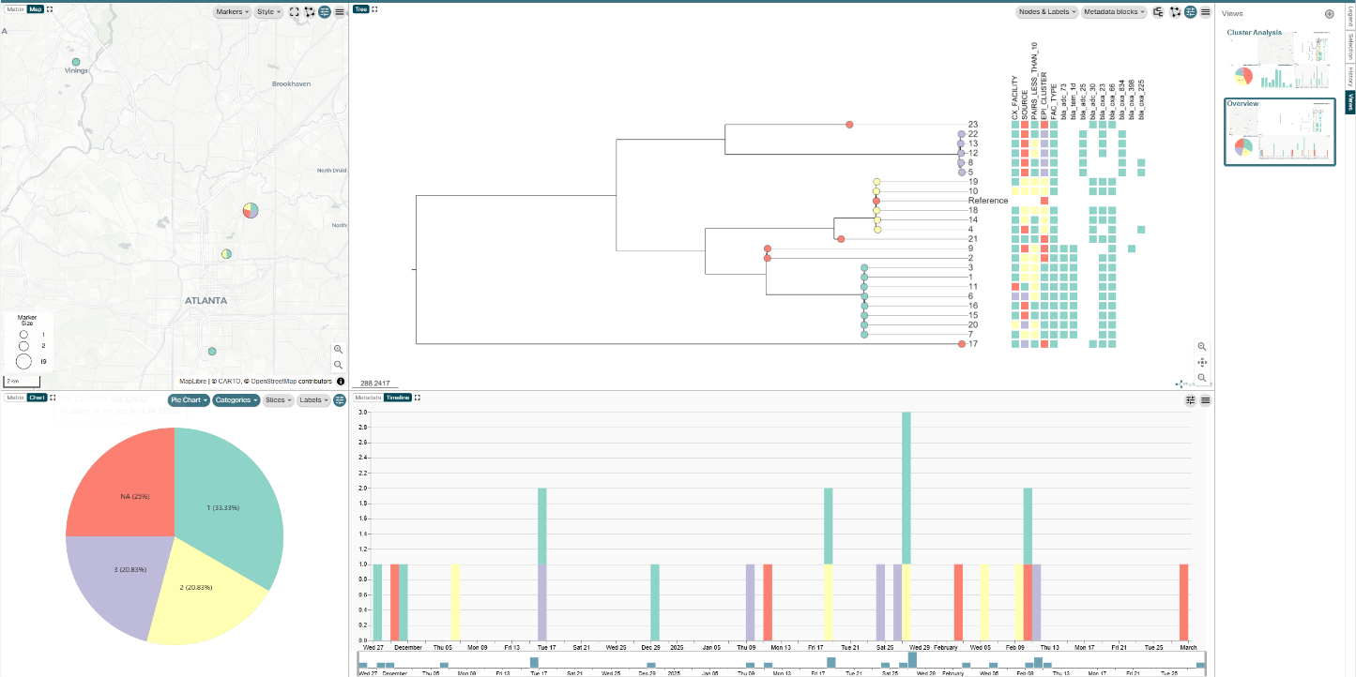

Stage 3: Save, Share, and Analyze

Step 11: Save and Share the Project
- Select the Save button in the upper-right corner.
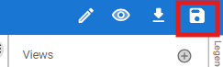
- Select Download as .microreact file.
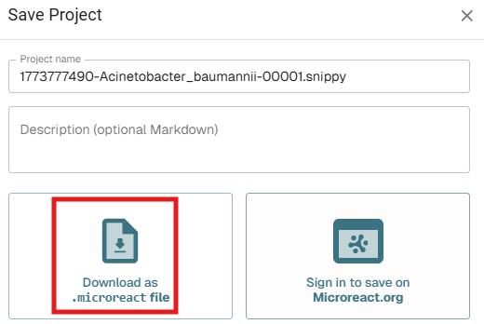
- The downloaded .microreact file can be shared with another authorized user, who can upload it to Microreact.
- To reopen the project, drag and drop the file into the upload area as described in Step 2.
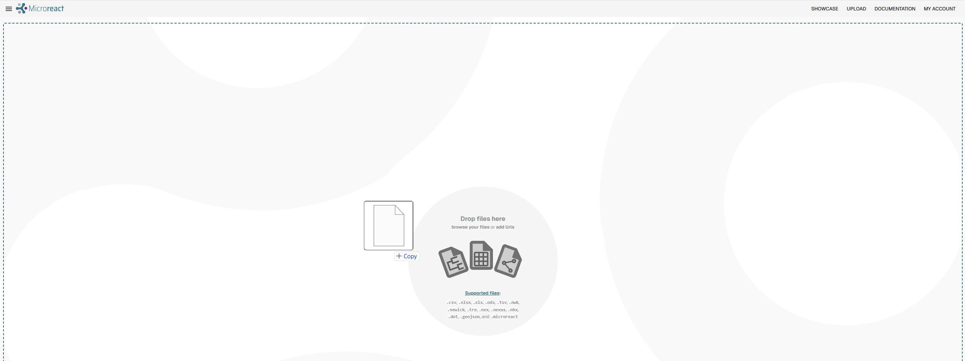

Step 12: Answer the Analysis Questions
Overview analysis
  - How many clusters are present, excluding NA?
  - Which cluster is the largest?
  - How many locations are represented?
  - What is the earliest isolate-collection date?
  - What is the latest isolate-collection date?
Cluster-level analysis
Cluster 1
    - What are the most common resistance mechanisms?
    - What is the earliest isolate-collection date?
    - Which facility collected the first isolate?
    - What is the latest isolate-collection date?
    - How many collection facilities are represented?
    - Which specimen sources are represented?
Cluster 2
    - What are the most common resistance mechanisms?
    - What is the earliest isolate-collection date?
    - Which facility collected the first isolate?
    - What is the latest isolate-collection date?
    - How many collection facilities are represented?
    - Which specimen sources are represented?
Cluster 3
    - What are the most common resistance mechanisms?
    - What is the earliest isolate-collection date?
    - Which facility collected the first isolate?
    - What is the latest isolate-collection date?
    - How many collection facilities are represented?
    - Which specimen sources are represented?
Cluster 1 interpretation (Open Entry)
  - The isolates were collected from about 4 facilities all within proximity to each other.
    - Could suggest localized regional circulation.
  - All facility types were ACH’s (Acute Care Hospitals)
    - possibility of healthcare-network transmission, shared patient movement, shared healthcare exposures, or prolonged colonization.
  - Isolates collected across roughly over a year, but have closely related lineage
    - Possible facility-associated or environmental reservoir, especially if cases repeatedly link back to the same facility, unit, room, equipment, or shared exposure.
    - The current tree and SNP matrix alone do not prove a reservoir. Additional epi evidence would be needed to support that as the primary source.
  - Possible takeaway:
    - Cluster 1 likely represents a broader persistent lineage with smaller recent transmission subclusters inside it.

